Lab - Encrypting and Decrypting Data using a Hacker Tool
Part 1: Create and Encrypt Files
Step 1: Create text files
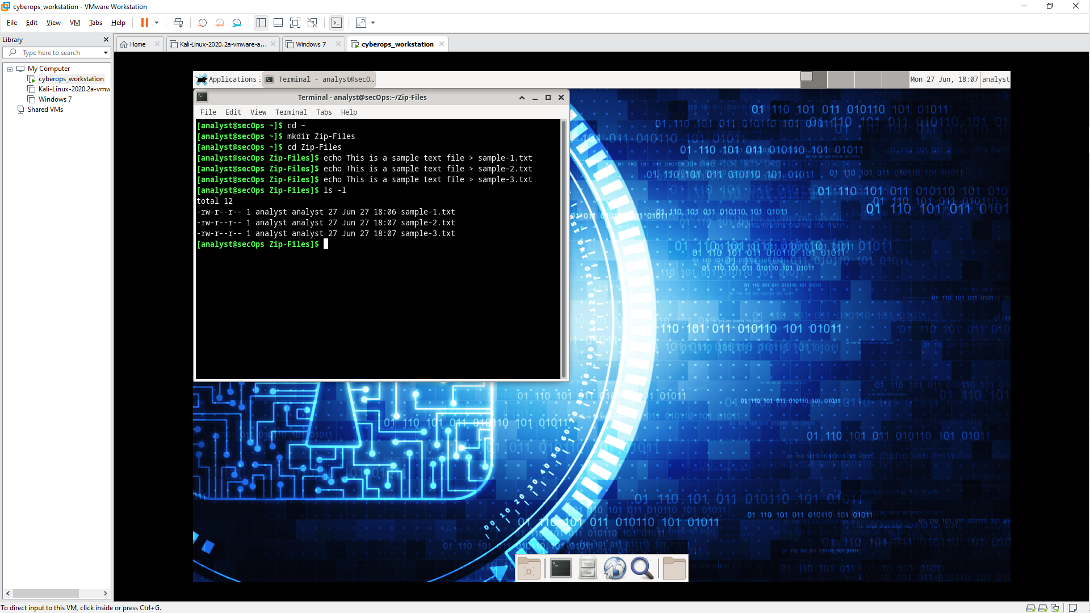

Step 2: Zip and encrypt the text files.
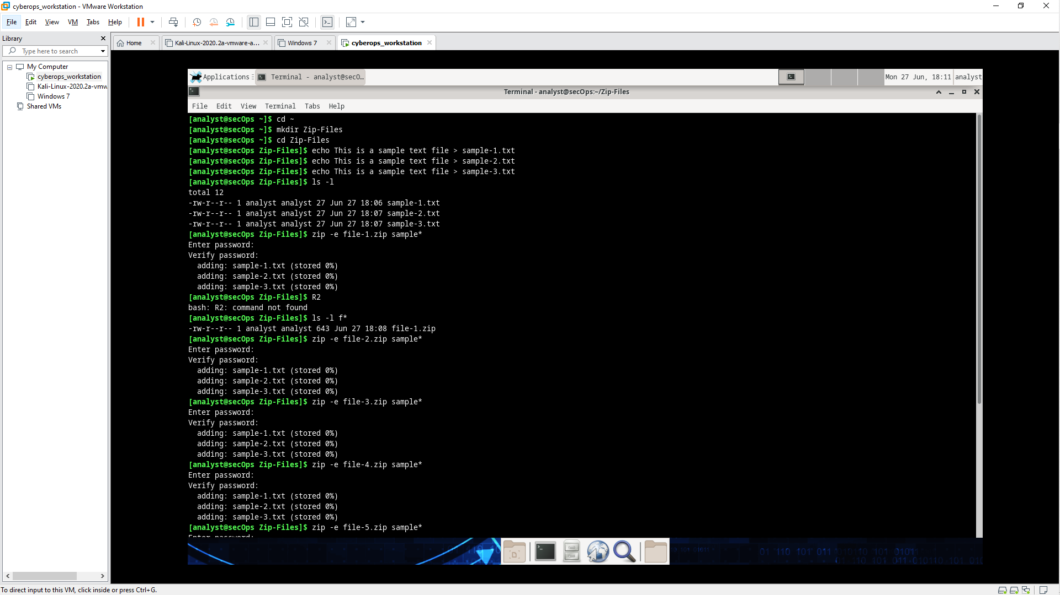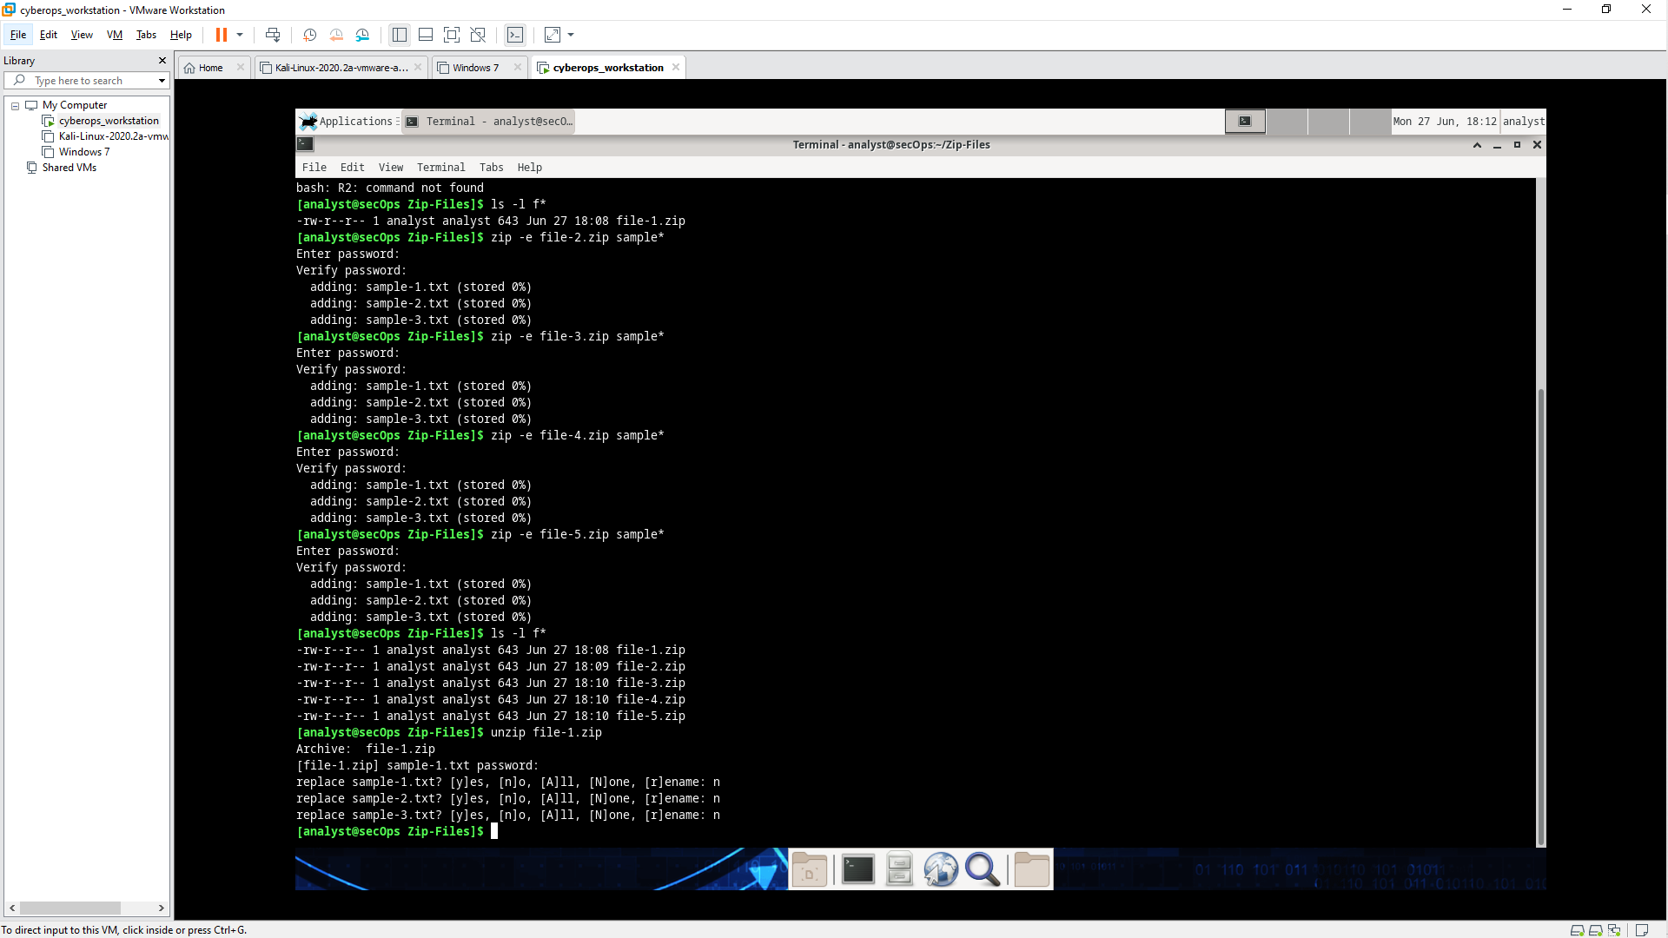

Part 2: Recover Encrypted Zip File Passwords
Step 1: Introduction to fcrackzip
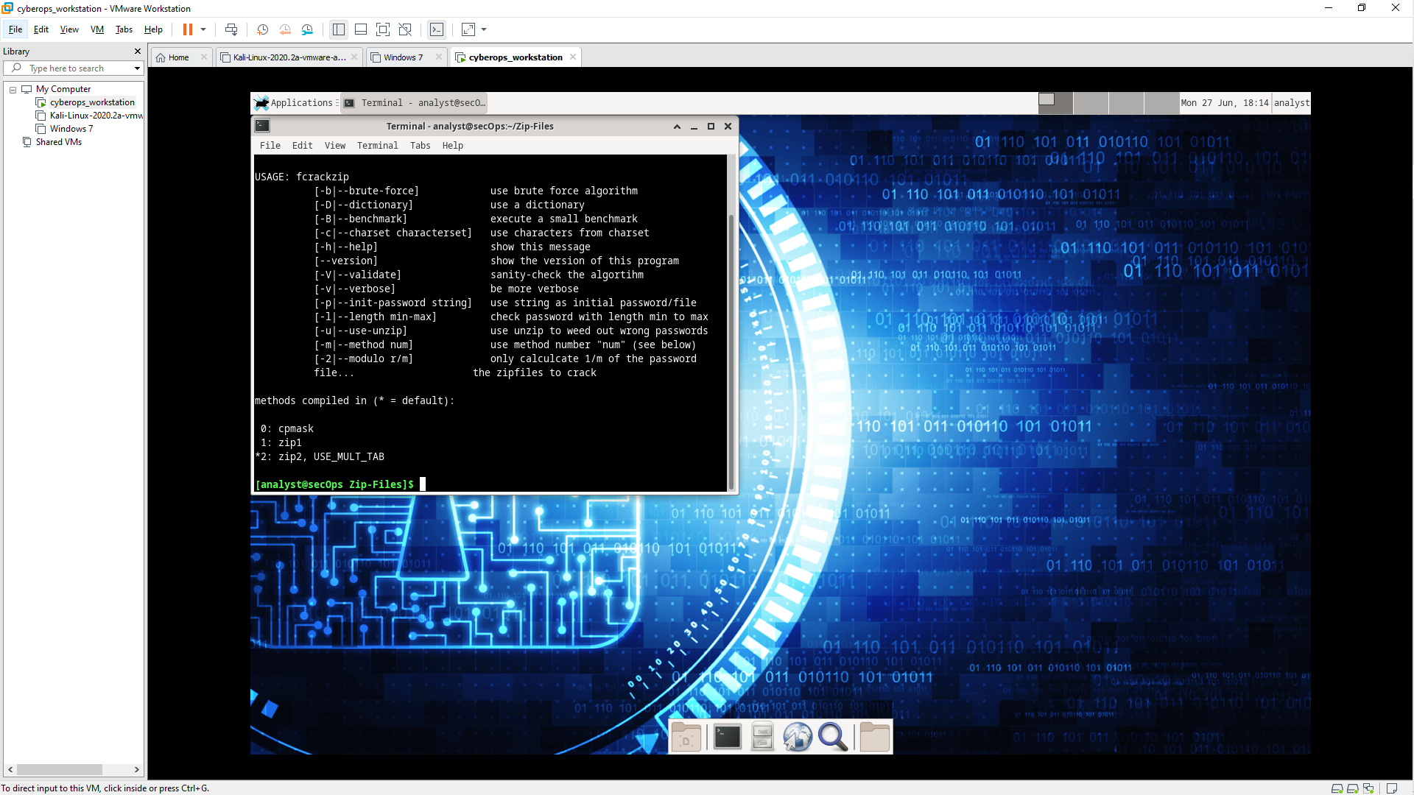

Step 2: Recovering Passwords using fcrackzip
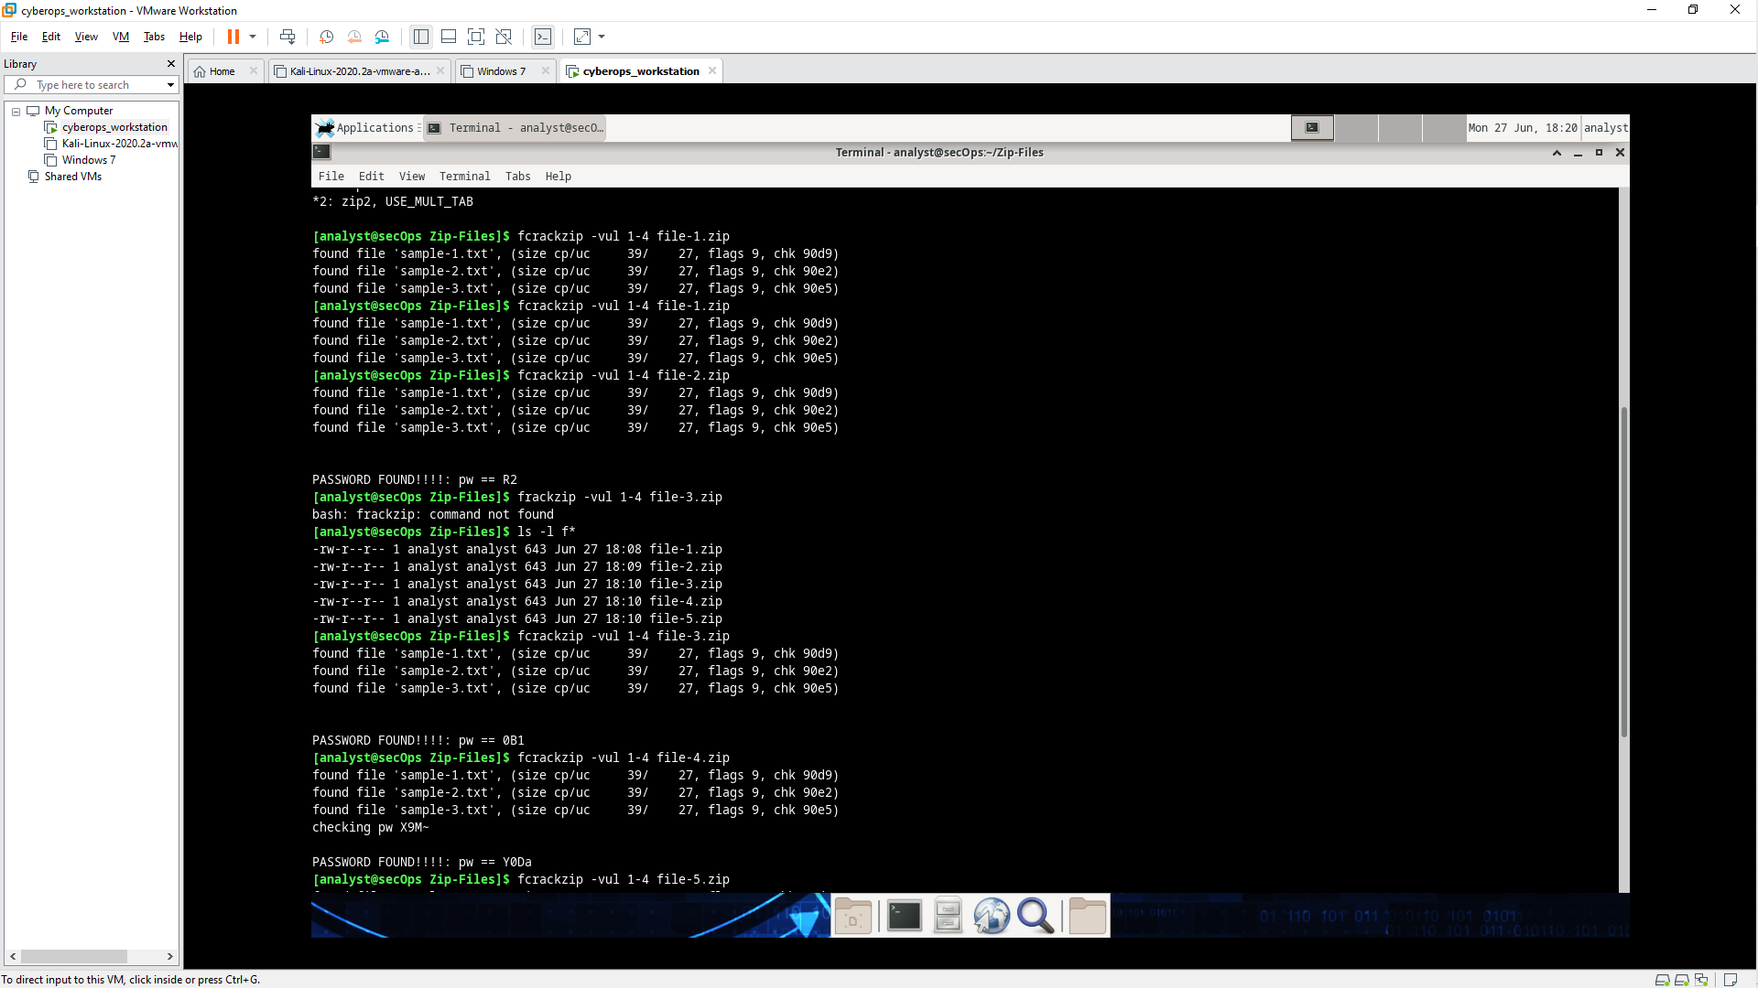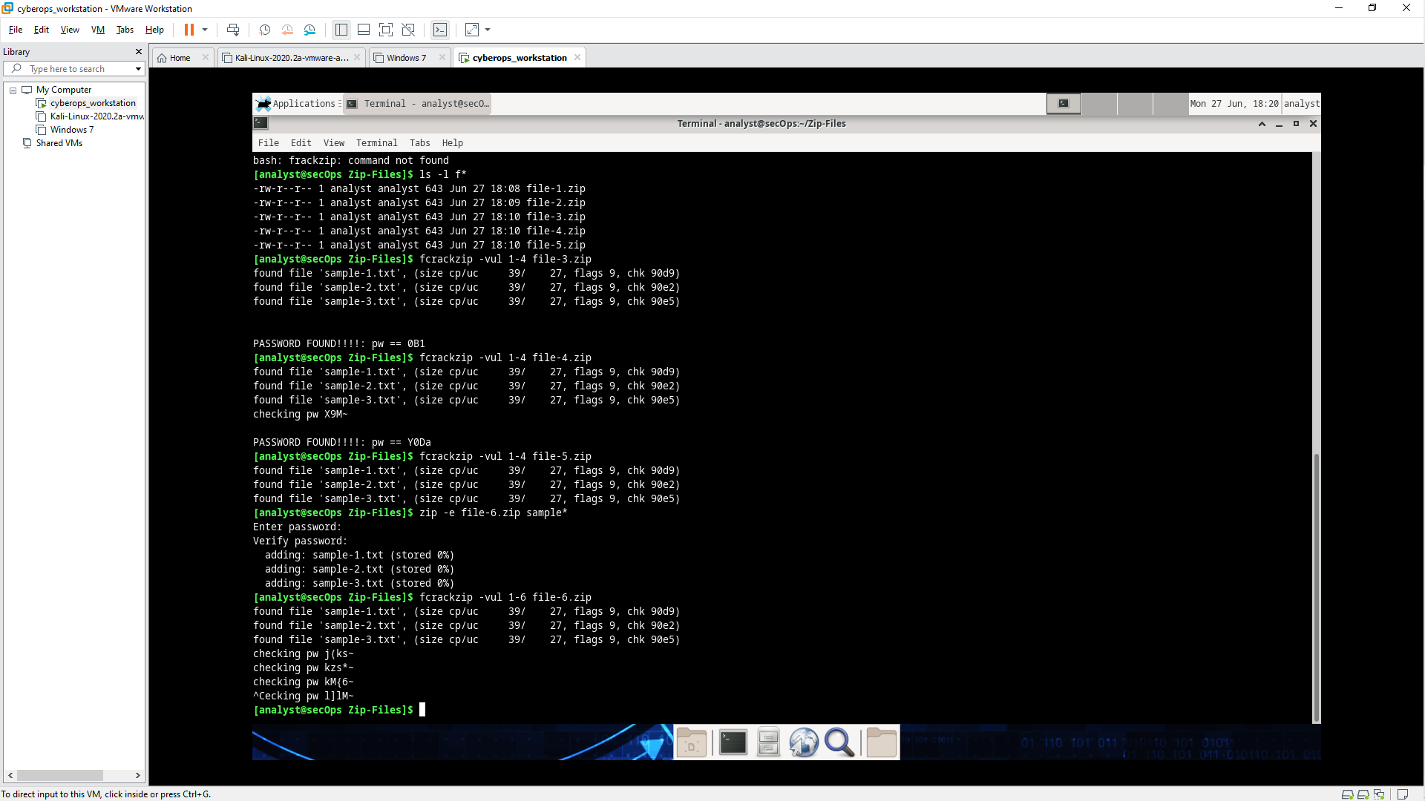
a) How long does it take to discover the password? – Fast
b) How long does it take to discover the password? – Fast
c) How long does it take to discover the password? – Fast
d) How long does it take to discover the password? – Fast
e) How long does it take to discover the password? – Fast
f) How long does it take to discover the password? – Fast
g) How long does it take fcrackzip to discover the password? – Slow
How long would you recommend a password needs to be for it to be secure? – 1 day

